MATH 341 Minitab Demonstration -- Lab 5 M. Blanco

**Comparing Two Sample Means**

Comparing Two Population Means: Small, Independent Samples, Equal variance

The t-value (-1.83) > t 0.025, 22 (-2.074) therefore we fail reject the null hypothesis in favor of the alternative hypothesis that the mean difference battery lifetime group A and group B is not 0. The p-value (0.08) > 0.05. We are 95% confident the mean difference battery lifetime is between 3.409 higher for group B and 0.209 higher for group A.

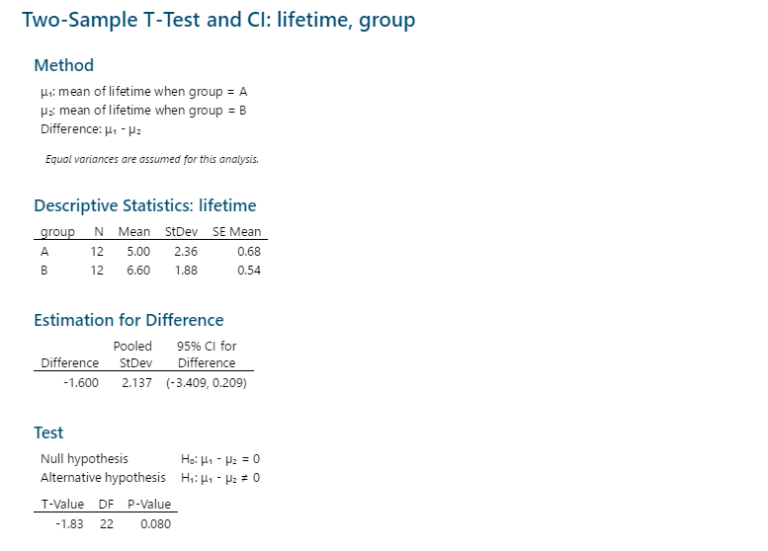

Comparing Two Population Means: Small, Independent Samples, Unequal variance

The t-value (-1.83) > t 0.025, 22 (-2.074) therefore we fail reject the null hypothesis in favor of the alternative hypothesis that the mean difference battery lifetime group A and group B is not 0. The p-value (0.08) > 0.05. We are 95% confident the mean difference battery lifetime is between 3.42 higher for group B and 0.22 higher for group A.

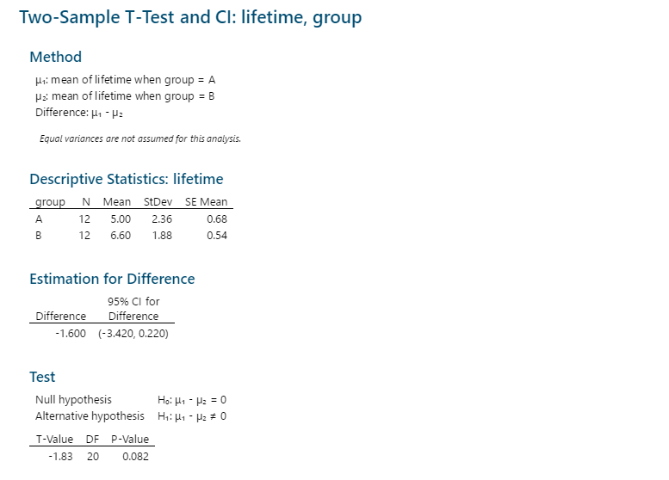

Comparing Two Population Means: Matched Pairs Samples

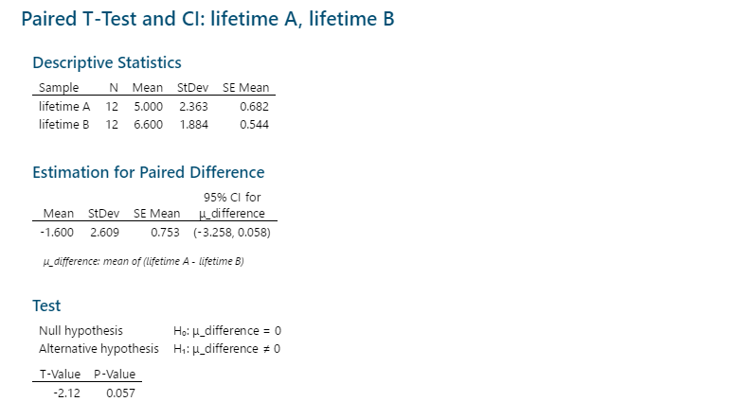

**Comparing Two Sample Variances**

F- test - **2** **Variances**

F 12,12,0.05 = 2.69. Since F (12.5450) > F 12,12,0.05 (2.69) we reject the null hypothesis in favor of the alternative that the mean battery lifetime variance is not the same.

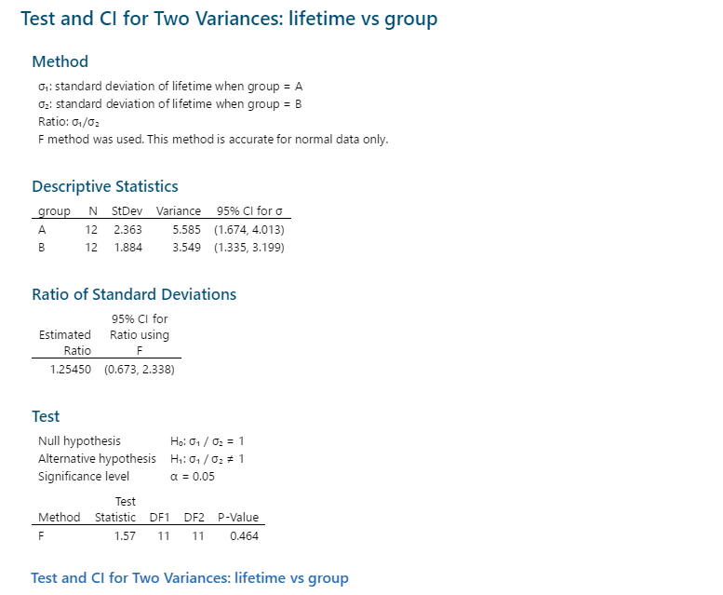



Chi-square test - **1** **Variance**

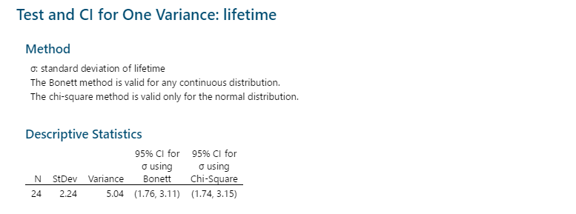

Now, let’s consider the data of **BATTERY.MPJ** above. Apply the **APPRORIATE** test statistic (Paired T test, 2-sample T test, Chi-square test, or F-test) to perform a confidence interval and hypothesis test. Use the output to answer the following questions:

1. Assume the lifetimes in group A and the lifetimes in group B are independent, construct a 90% confidence interval for the difference between mean **lifetime** of **group A** and mean **lifetime** of **group B**. Interpret your confidence interval. What is the sampling errors?

Apply an appropriate Hypothesis Test to verify if there is difference between mean **lifetime** of **group A** and mean **lifetime** of **group B**. What is your decision? Is your decision consistent with your confidence interval above?

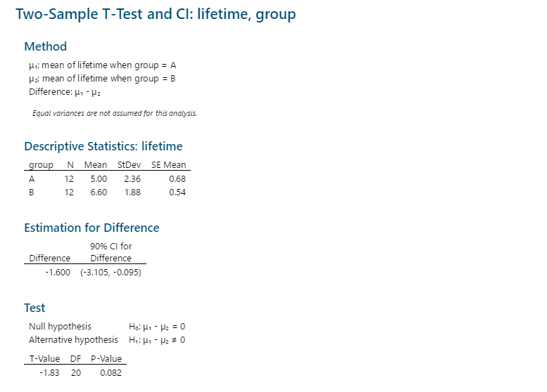

1. Assume the lifetimes in group A and the lifetimes in group B are matched, we are now interested in if the mean differences between **lifetime** of **group A** and **lifetime** of **group B** is

0. Apply an appropriate Hypothesis Test use α=0.05. What is your test statistic and p-value? What is your final decision?

Construct a 95% confidence interval for the mean differences. Interpreter your result, does it consistent with your hypothesis test above?

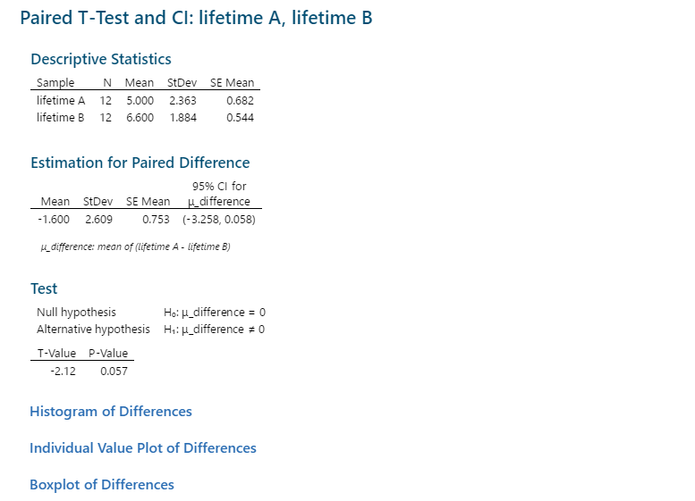   

1. We would like to evaluate whether the variance of **lifetime** (two groups together)is bigger than 5 at the significant level of 0.01. Perform a one variance Hypothesis Test. What is the test statistic and p-value? What is your decision (can we reject the null hypothesis)? Why or why not?

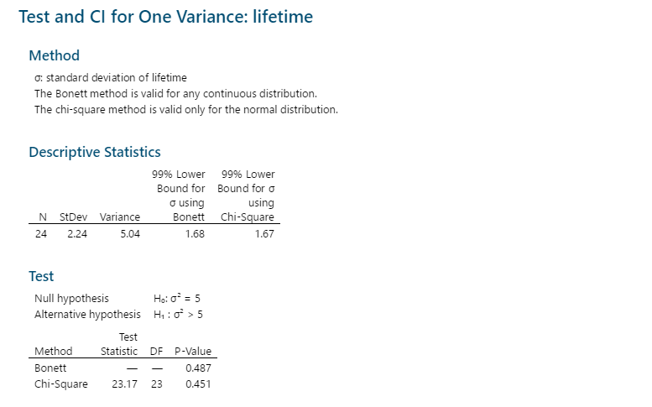

1. Construct a 90% confidence interval for the ratio between the variance of **lifetime** of **group A** and the variance of **lifetime** of **group B**. Interpret your confidence interval. What is the observed ratio of variances?

We would like to see if the variance of **lifetime** of **group A** is significantly different from that of **lifetime** of **group B** at level of 0.1. Perform a two variances Hypothesis Test. What is the test statistic and p-value? What is your decision (can we reject the null hypothesis)? Does your decision agree with your confidence interval above?

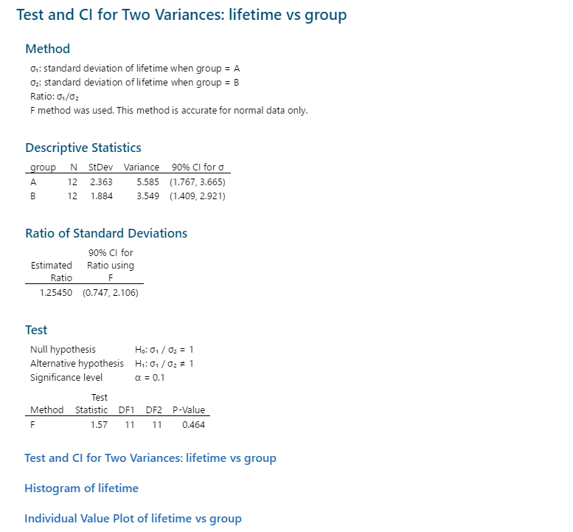



2